**PRACTICAL 1**

**Aim: Install Android Studio Create a virtual device, Create and Run Hello World on emulator and device, Explore project layout, Generate and view log statements, Explore manifest file.**

**Steps to Install Android Studio on MacOS:**

1. Launch the Android Studio DMG file.
2. Drag and drop Android Studio into the Applications folder, then launch Android Studio.
3. Choose whether to import previous Android Studio settings, then click OK.
4. Complete the Android Studio Setup Wizard, which includes downloading the Android SDK components that are required for development.

**Creating a Virtual Device:**

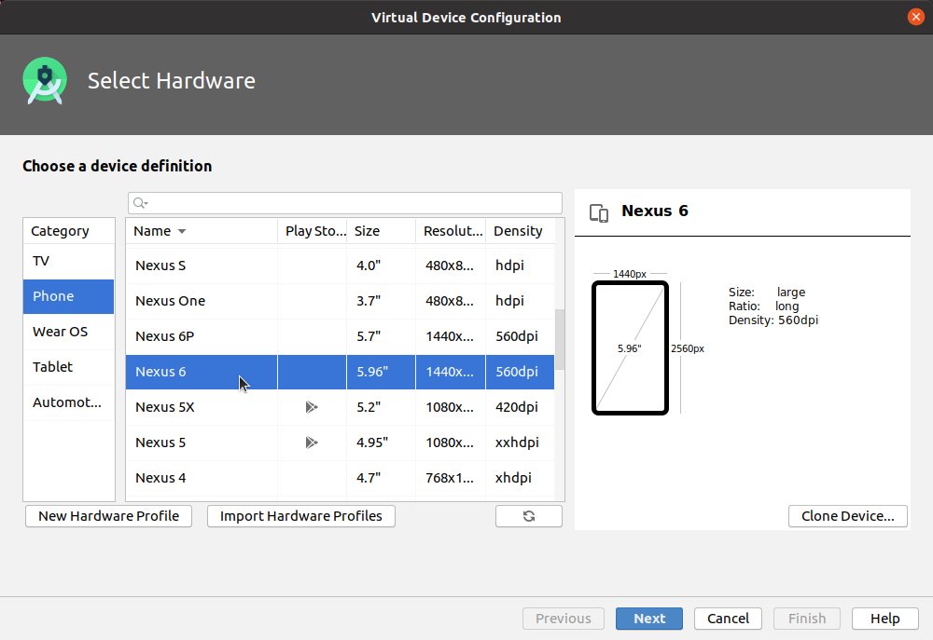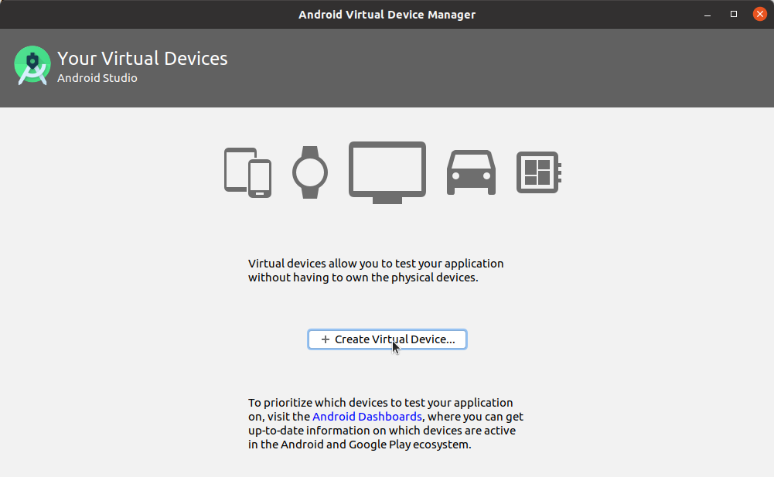

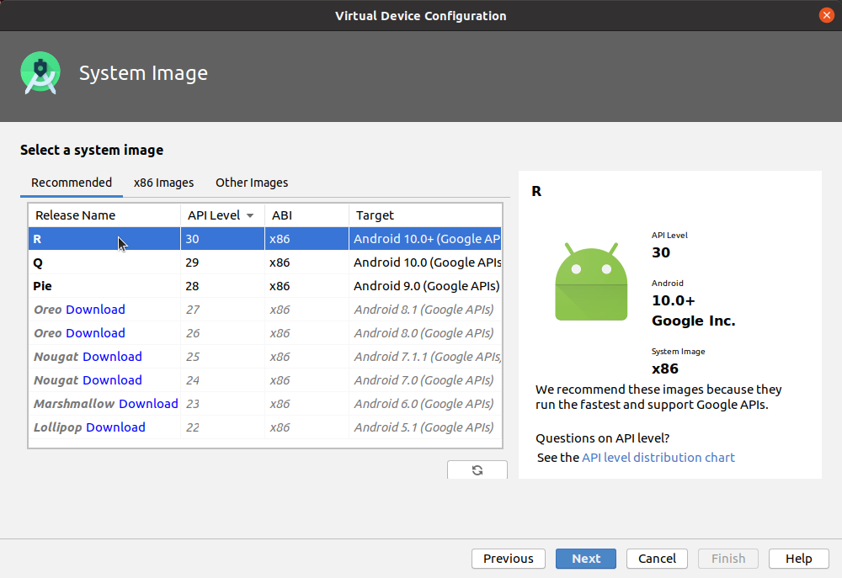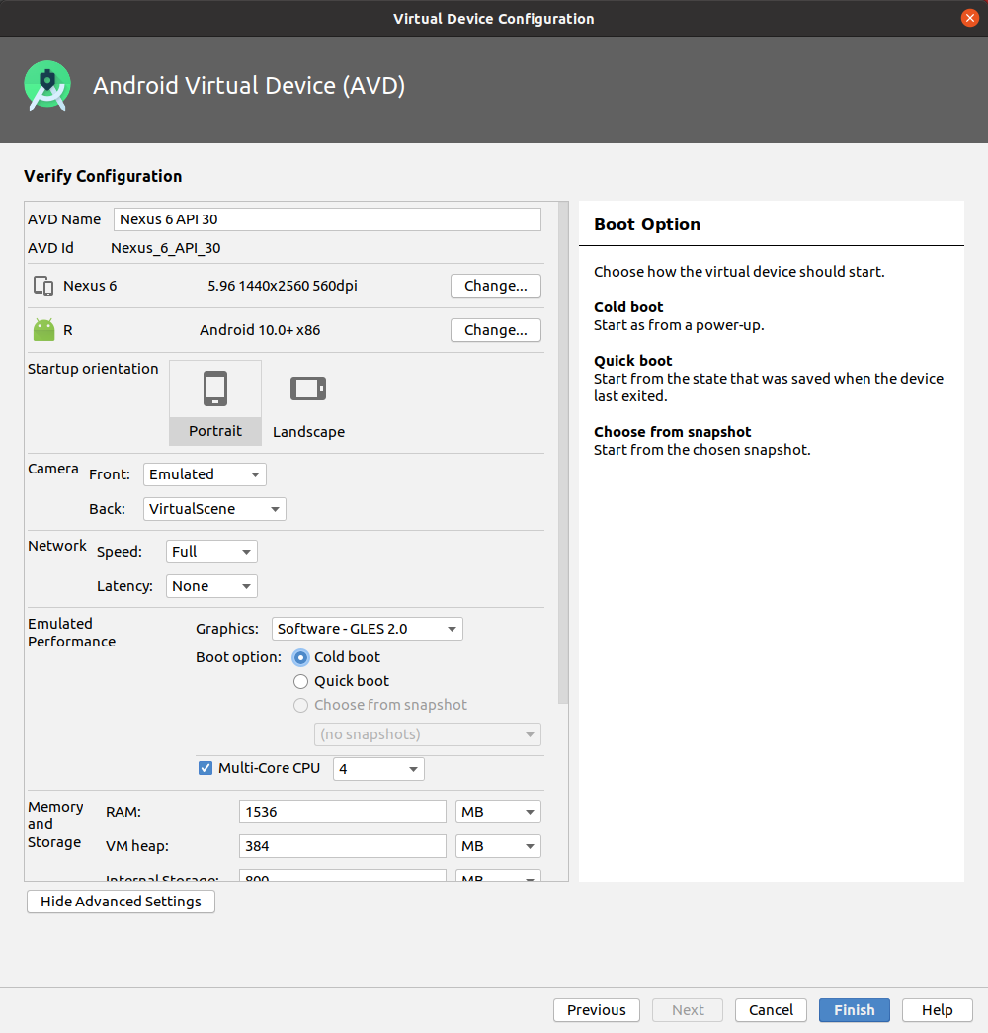

**Code:**

**JAVA FILE: (MainActivity.java)**

package com.example.practical1;

import androidx.appcompat.app.AppCompatActivity;

import android.os.Bundle;

public class MainActivity extends AppCompatActivity {

@Override

protected void onCreate(Bundle savedInstanceState) {

super.onCreate(savedInstanceState);

setContentView(R.layout.*activity_main*);

}

}

**XML FILE: (activity_main.xml)**

<?xml version="1.0" encoding="utf-8"?>

<androidx.constraintlayout.widget.ConstraintLayout xmlns:android="http://schemas.android.com/apk/res/android"

xmlns:app="http://schemas.android.com/apk/res-auto"

xmlns:tools="http://schemas.android.com/tools"

android:layout_width="match_parent"

android:layout_height="match_parent"

tools:context=".MainActivity">

<TextView

android:id="@+id/textView"

android:layout_width="wrap_content"

android:layout_height="wrap_content"

android:layout_marginTop="50dp"

android:text=" Name: Angat Shah \n Enrollment No: 202203103510097 \n Branch: B.Tech CSE"

app:layout_constraintEnd_toEndOf="parent"

app:layout_constraintHorizontal_bias="0.497"

app:layout_constraintStart_toStartOf="parent"

app:layout_constraintTop_toTopOf="parent"

tools:ignore="MissingConstraints" />

<TextView

android:layout_width="wrap_content"

android:layout_height="wrap_content"

android:text="HELLO WORLD"

android:textSize="21dp"

app:layout_constraintBottom_toBottomOf="parent"

app:layout_constraintEnd_toEndOf="parent"

app:layout_constraintStart_toStartOf="parent"

app:layout_constraintTop_toTopOf="parent" />

</androidx.constraintlayout.widget.ConstraintLayout>

**Output:**

